# Predicting the right business

1. **Introduction/Business Problem**:

1.1 Introduction:

KMax is a well-established leading business company in India. They have succeeded in various business areas like retail stores, automobile stores, textile industry, jewelry, petroleum industry etc. They are currently looking for venturing into a new business area. They are looking at setting up a new business in Mysuru,India which is a famous tourism place in Karnataka and earns huge revenue to the state. They want to do a proper analysis and decide which business would be appropriate for such a place so that though they do not gain much profit, they do not get into a loss.

They have decided to identify one of the three business

1. Restaurant
2. Shopping Mall
3. Resort with outdoor activities

They have selected the location to set up the business as Ringroad which is near the industrial area and has major IT companies near by and the huge population stays in this area

1.2 Problem

Data that might contribute to determining the right business would be to explore the near-by venues and identify the total number of restaurants, shopping malls and resorts present in the chosen area. Having found the number, this project aims to predict whether the KMax company can select one of the three businesses or should they consider any other idea. If they can consider one among the three, then which is the best out of the three so that they can run the business without much loss.

1. **Data**

In order to identify the right profitable business to be set up, I will be using the data that is fetched by giving the Infosys,Mysuru as the search location and explore the top 100 nearby venues within 10 KM radius.

Based on the venues identified analysis would be done on the data to check if one of the three business ideas is good to proceed or should we consider suggesting a different idea to the user.

Below is a visual representation of the venues near by Infosys which will be converted to a dataframe and used for analysis.

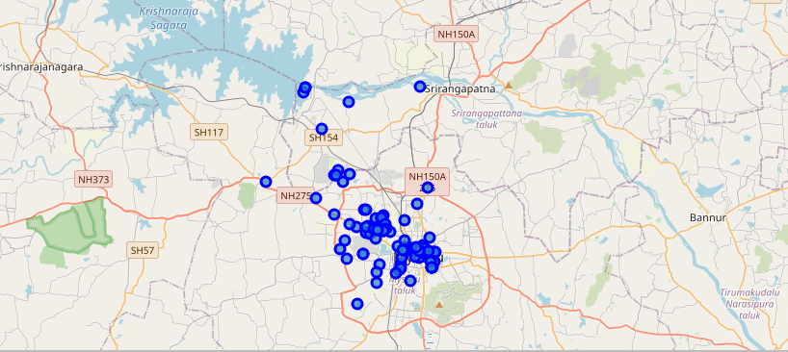

1. **Methodolgy:**

I have gathered the top 100 venues near the Infosys Mysore within the distance of 10 KM. In order to carry out the task, I have used he foursquare location API.

Below are the steps followed:

1. Fetch the latitude and longitude of the given location
2. Define the foursquare credentials and version
3. Construct the URL to fetch the near by venues
4. Send the url request and fetch the json values
5. Clean the Json and store it in dataframe

A sample of the dataframe is as shown below

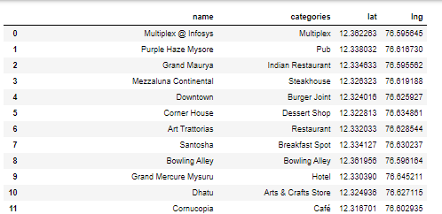

1. Plot the venues on the map



1. Group the venues based on the category and display them in the descending order. This will give us an idea on category wise top venues that are present nearby.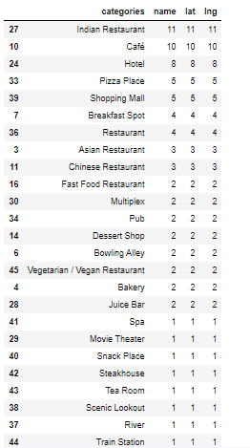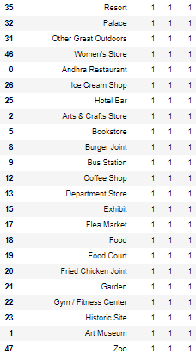
2. **Results:**

From the above grouped data, it is very clear that there are maximum number of Indian restaurants in the given locality. There are 5 shopping malls present nearby. Apart from the 11 Indian restaurants, if you exclude the shopping mall 9 out of the top 10 places are related to eateries. Also on the other hand, there is only one Scenic Lookout, Resort, Outdoor activities, Icecream shop etc

1. **Discussion:**

Based on the above result, it looks like it is not an ideal suggestion to start a restaurant in the given locality as there are so many eateries nearby and it would be difficult for the KMax company to establish and compete with the existing competitors. Also there are around 5 shopping malls. For a city like Mysore where the population is less compared to major cities like Bangalore and Mumbai, there would not a great business that can be done from the shopping malls. Hence the last option resort with outdoor activities may sound as the better suggestion among the three. Since there are lot of IT companies around and Mysore being a great tourism center, a resort with more outdoor activities would attract more crowd and prove to be a success one.

1. **Conclusion:**

Hence based on the exploratory analysis done, we would suggest the KMax company to look for setting up a resort with outdoor activities or even think of few more business ideas that are different from the given list.